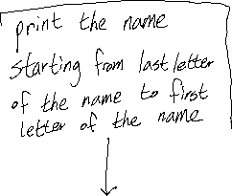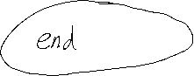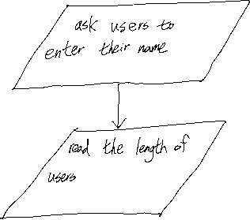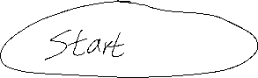

|  |  |  |
| --- | --- | --- |
| Test setting | User input | Expected result |
| Please enter your name: | Hyunjae | eajnuyH |
|  | Kim | miK |
|  | IU | UI |
|  | Park | karP |
|  | Lee | eeL |
|  | ele | Ele |